Congo Red Staining Protocol

I. Overview 4

A. Overview 4

B. Staining Interpretation: 4

II. Required Materials 4

A. Abcam Congo Red Stain Kit (Abcam, SKU#: ab150663) 4

B. Microscope slides with tissue section(s) 4

C. Hydrophobic Barrier Pap Pen (Vector Labs, SKU#: H-4000) 4

D. Solutions required but not supplied by Abcam (prepare beforehand): 4

E. Other useful equipment: 4

III. Setup: 4

IV. Assay Procedure 5

A. Preliminary Steps – do BEFORE applying first stain: 5

B. Staining & Wash Steps 6

C. Mounting Coverslip 6

D. Summary table of procedure: 8

V. Appendix I: Figures 9

VI. Appendix II: Safety Precautions & Disposal Instructions 11

VII. Appendix III: Troubleshooting Tips, Common Errors, & Helpful Info 12

VIII. Appendix IV: Website Links 13

1. Overview
   1. The Amyloid Stain (Congo Red) is intended for use in the histological visualization of amyloid in tissue sections. Examination under a polarizing microscope results in green birefringence of amyloid.
   2. Staining Interpretation:

|  |  |
| --- | --- |
| Amyloid | Red to Pink |
| Erythrocytes | Light Orange |
| Eosinophil Granules | Orange to Red |
| Nuclei | Blue |
| (from Abcam Congo Red Stain Kit Protocol Booklet, [https://www.abcam.com/congo-red-stain-kit-amyloid-stain-ab150663.html#](https://www.abcam.com/congo-red-stain-kit-amyloid-stain-ab150663.html)) | |

1. Required Materials
   1. Abcam Congo Red Stain Kit (Abcam, SKU#: [ab150663](https://www.abcam.com/congo-red-stain-kit-amyloid-stain-ab150663.html))
   2. Microscope slides with tissue section(s)
   3. Hydrophobic Barrier Pap Pen (Vector Labs, SKU#: [H-4000](https://vectorlabs.com/products/histology/immedge-hydrophobic-barrier-pen))
      1. See **Figure 1**
   4. Solutions required but not supplied by Abcam (prepare beforehand):
      1. Tap Water (~1L/stain)
      2. D.I. H2O (~200mL/stain)
      3. 95% Ethanol (~200mL/stain)
      4. 2x 100% Ethanol (2x ~200mL/stain)
      5. Xylenes Solution (HistoPrep, SKU#: [HC700-1GAL](https://www.fishersci.com/shop/products/xylene-fisherbrand-histoprep/HC7001GAL))
      6. Permount Mounting Medium, Electron Microscopy Science (VWR, SKU#: [100496-550](https://us.vwr.com/store/catalog/product.jsp?catalog_number=100496-550))
   5. Other useful equipment:
      1. SHURStain Manual Stainer Rack, 12 position (VWR. SKU#: [89238-898](https://us.vwr.com/store/product?keyword=89238-898))
      2. Flat surface to lay slides on while they stain (since stains will be pipetted onto slides)
2. Setup:
   1. Often depends on personal preference.
      1. I (Andrew) like to have all reagents and washes pre-made before I start. I keep my reagent/washes for the next step close-to-hand so I can quickly transition between staining and washing steps. Once a reagent or wash is used, I set it outside my work area (i.e., the fume hood) to signal it has been used and is queued for discard. Also, it gives me more room to work and reduces the chance of spillage.
   2. An example image (**Figure 2**) of a past staining setup can be found in Appendix I.
3. Assay Procedure
   1. Preliminary Steps – do BEFORE applying first stain:
      1. Equilibrate slides with frozen sections to room temperature for 30 mins
      2. Equilibrate all reagents to room temperature just prior to use.
      3. Abcam reagents should be stored at room temp already.
      4. While slides and reagents equilibrate, make/pour 200mL of D.I. H2O, 95% Ethanol, 100% Ethanol, and Xylene into the SHURStain wells.
      5. NOTE: The green SHURStain wells are reportedly “Xylene resistant”.
      6. These wells are made to hold up to 250mL, but filling them to this volume will completely submerge the slides, which, when dunked in alcohol, will strip away any hand-written labels on the slides. Hence, the suggestion to only use 200mL to preserve labels and conserve reagents.
      7. Another solution is to label with pencil instead of marker. Pencil labels can withstand an alcohol wash, but are relatively faint to begin with.
      8. Gently agitate Abcam reagents before use.
      9. NOTE: Better to agitate reagents immediately prior to using, but any agitation is better than none.
      10. Apply hydrophobic barrier around sections with Pap Pen (see **Figure 3** for example).
      11. Using a pre-made template sheet (**Figure 4**), trace a box around tissue sections.
          * 1. ½” X ½” box is preferred (to concentrate solutions on tissue section and prevent run-off).
            2. Double layer PapPen around the tissue to reduce chances of solution run-off – i.e., increase the thickness of the hydrophobic cage around tissue.
   2. Staining & Wash Steps
      1. Apply 4-6 drops (~160μL) of **Hematoxylin** for 5 seconds.
         1. Rinse/dunk in **stagnant tap water** – i.e., not running water; taken from any regular sink faucet.
            1. See **Figure 5** for example image.
         2. Flick off as much water as possible before adding next reagent, *but do not allow to dry completely!*
      2. Apply 4-6 drops (~160μL) of **Bluing Reagent** for 15 seconds.
         1. Rinse slides in **distilled water**.
         2. Dip slides in **95% Ethanol** for 5 seconds.
      3. Apply 4-6 drops (~160μL) of **Congo Red Solution** for 1 minute; cover all slides with a clean staining box (or multiple if necessary) while reagent is on slide (**Figure 6A** & **Figure 6B**)

[**NOTE:** cover slides during this step to obstruct airflow across surface of the slides. This is done to prevent Congo Red from evaporating while staining tissue, as this causes crystallization of the reagent and results in poor tissue differentiation and poor staining overall.]

* + 1. Rinse in **100% Ethanol** (2x changes for 20 seconds each)
    2. Place slides in **Xylenes Solution** for 2 minutes.
    3. Allow slides to dry before mounting coverslips.
  1. Mounting Coverslip
     1. Once slides have dried completely, dunk in 100% Ethanol for 20 seconds, tap-off, then dunk in Xylene for 20 seconds and tap-off.
        1. NOTE: mount coverslip while the slide is still wet from Xylene. DO NOT allow to completely dry before applying Permount.
     2. Using Permount Mounting Medium, dab a line NEXT TO tissue (NOT directly on it). Take coverslip and touch the edge of it to side of slide where Permount was placed, creating a region of shared contact between the slide and coverslip with the Permount. Then, guide the body of the coverslip to gently “fall” across the tissue and body of the slide.
  2. Summary table of procedure:

|  |  |
| --- | --- |
| *Step (stain/wash)* | *Time (minutes)* |
| Hematoxylin | **5 minutes** |
| wash | Tap water |
| Bluing Reagent | **30 seconds** |
| wash | Rinse slides in distilled water, followed by 5 seconds of 95% Ethanol |
| Congo Red | **20 minutes** |
| Final wash | *Tap off in between dunks:* 20 seconds in 2x changes of 100% Ethanol, followed by 1 minute in Xylene. |

1. Appendix I: Figures

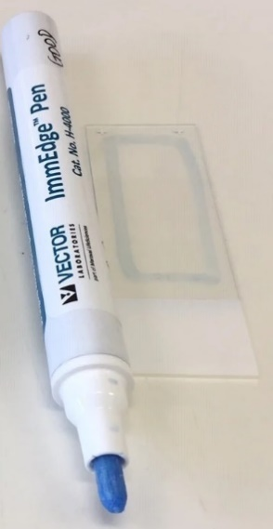

**Figure 1**: ImmEDGETM Hydrophobic Barrier Pap Pen

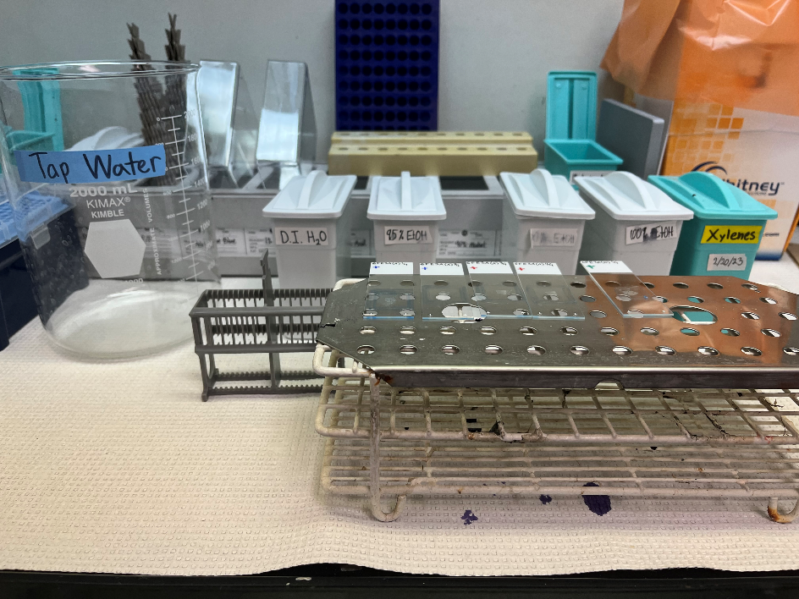

**Figure 2**: Assay setup prior to start

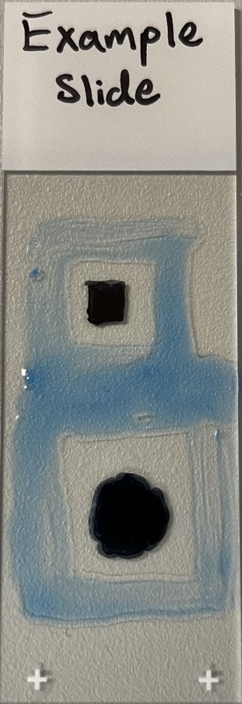

**Figure 3**: Example slide showing hydrophobic barriers drawn with dimensions (top) ½“ x ½“ and (bottom) ¾“ x ¾”.

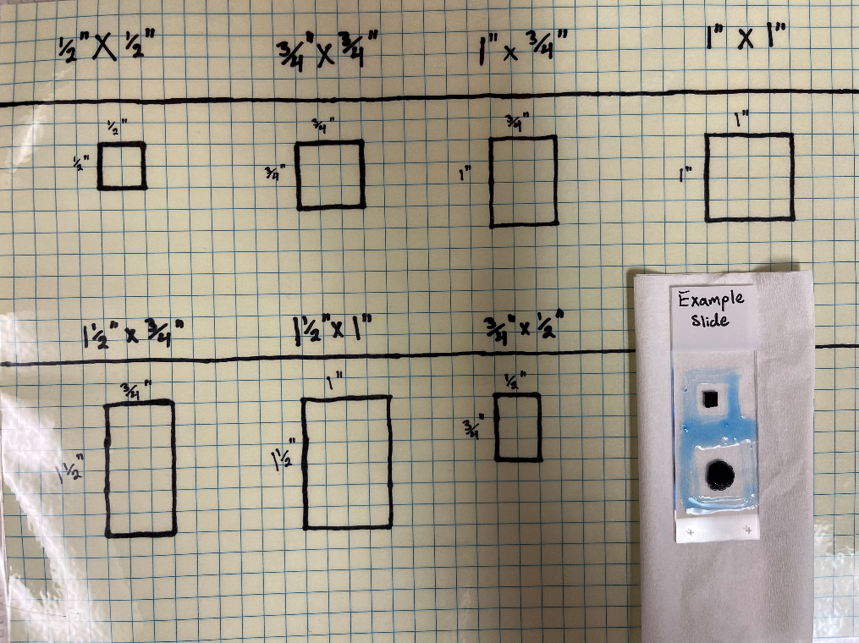

**Figure 4**: Template sheet for tracing standardized hydrophobic cages around tissue sections with Pap Pen (Hydrophobic Barrier Pen).

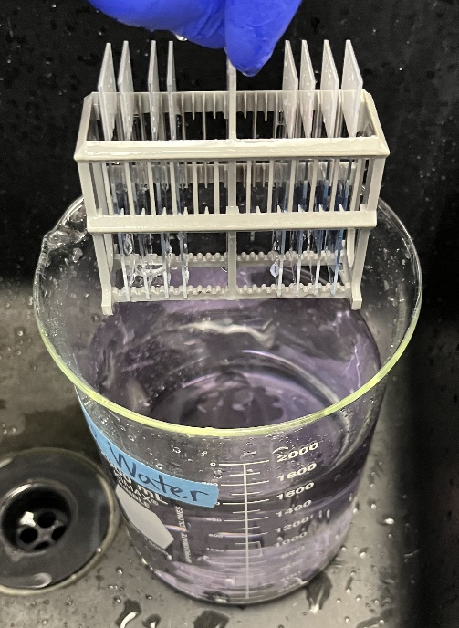

**Figure 5**: Tap water rinse in 2L glass beaker.

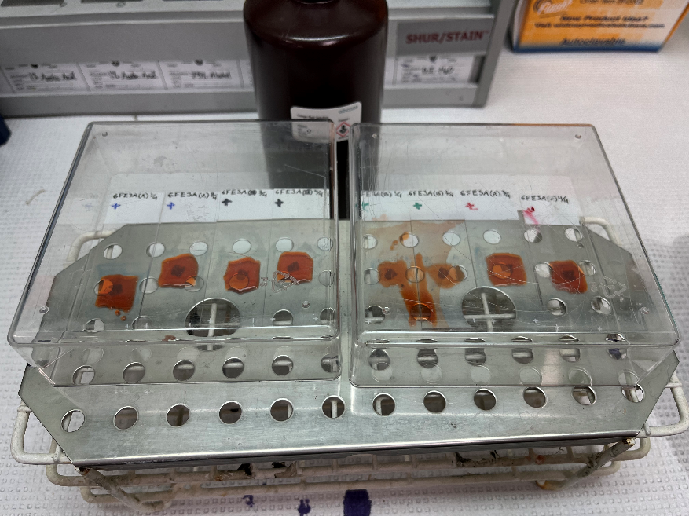

**Figure 6A**: Congo Red staining step with slides covered (image taken from above).

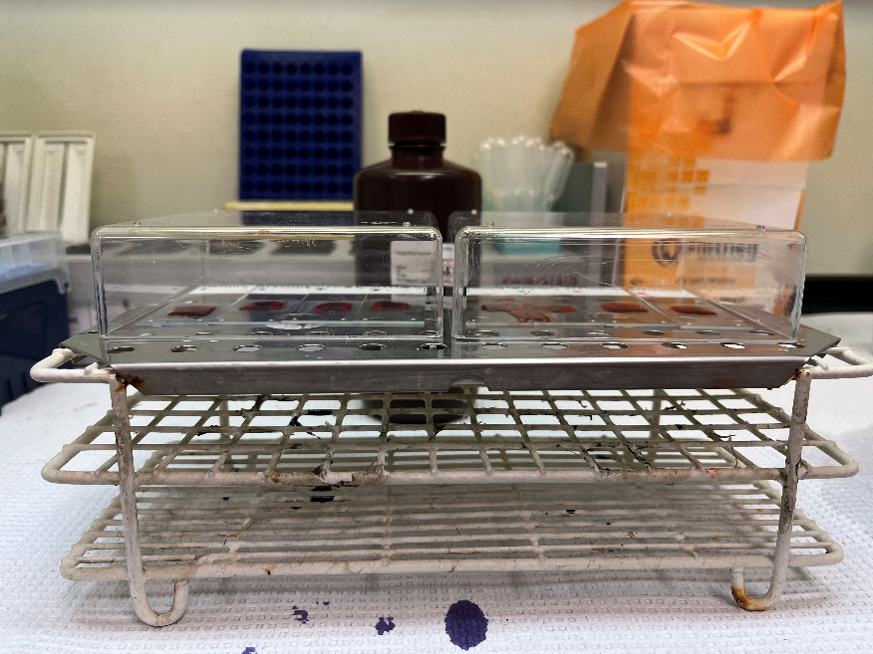

**Figure 6B**: Congo Red staining step with slides covered (image taken from front).

1. Appendix II: Safety Precautions & Disposal Instructions
   1. Xylene is extremely toxic!
      1. Always handle inside fume hood
      2. Always wear gloves and lab coat while handling; safety goggles probably wouldn’t be a terrible idea either.
      3. **DO NOT DISPOSE IN SINK**
         1. There should be a separate, labeled glass 4L bottle for Xylene waste
   2. Hematoxylin disposal
      1. Any special requirements? Pretty sure this is toxic…
   3. All other chemicals can be safely washed down the sink
2. Appendix III: Troubleshooting Tips, Common Errors, & Helpful Info
   1. What if you are running the procedure alone and cannot perfectly synchronize stain application and removal?
      1. Do your best, sometimes you’ll be on your own and it can’t be helped.
      2. I (Andrew) personally will try to optimize efficiency by adjusting my setup before each stain so the materials needed for the next few steps are readily available and easily accessible before I need them.
         1. Setting up like this also forces you to run through the next step in your head, which acts as a rehearsal and helps increase efficiency when it comes time to act.
      3. I will also make sure that the 1st slide I put the stain on is the 1st slide I tap off once the timer goes off; this helps keep the application time relatively equal for all slides.
   2. Congo Red Stain:
      1. NOTE: slides are covered to reduce airflow over tissue during this step. This is an attempt to prevent Congo Red from drying out on tissue, as this causes crystallization, resulting in poor tissue differentiation and a poor stain overall.]
      2. We had trouble with the Congo Red stain crystallizing on the slide during the 20-minute incubation step. We solved this by…
         1. Using the hydrophobic barrier pen to keep the solution concentrated on the section instead of letting it flow all over the entire slide.
         2. Using the plastic covers to reduce airflow over the slides, thus reducing rate of evaporation and preventing crystallization from taking place.
3. Appendix IV: Website Links
   1. Abcam Congo Red Stain Kit: <https://www.abcam.com/congo-red-stain-kit-amyloid-stain-ab150663.html>
   2. Microscope slides:
   3. ImmEdge® Hydrophobic Barrier PAP Pen: <https://vectorlabs.com/products/histology/immedge-hydrophobic-barrier-pen>
   4. HistoPrep Xylenes: <https://www.fishersci.com/shop/products/xylene-fisherbrand-histoprep/HC7001GAL>
   5. Permount Mounting Medium: <https://us.vwr.com/store/catalog/product.jsp?catalog_number=100496-550>
   6. SHURStainTM Manual Stainer Rack, 12 position: <https://us.vwr.com/store/product?keyword=89238-898>